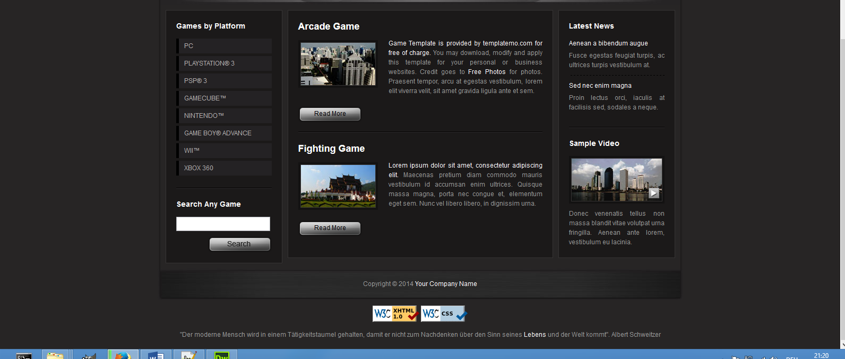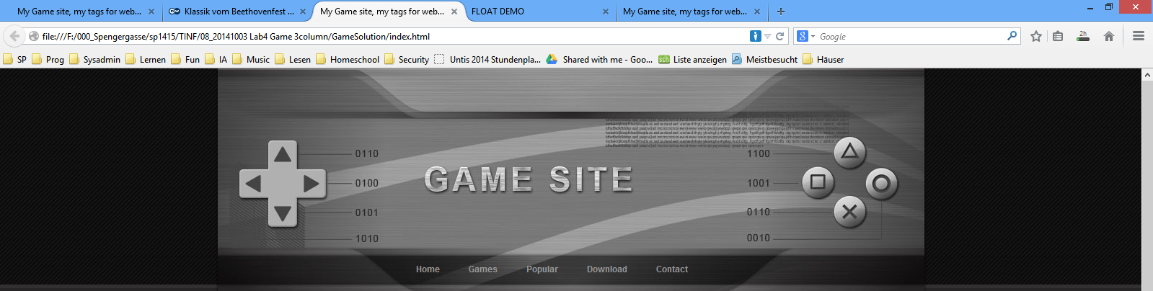

**Formatting Instructions:**

**body**: font-size: 12px; color: #999;

background: #272525 url(images/templatemo_top_bg.jpg) repeat-x;

Banner container: width: 980px, height: 250px

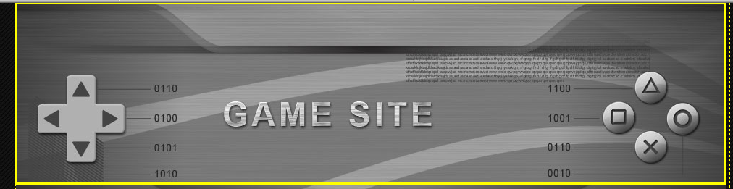

**Horizontal Menue**: width: 500px; height: 65px; color for hyperlink #999999;

hover color #ffffff

**Sidebars and content container**:

background: #1b1919;

border: 1px solid #363434;

**Use this text** for both games in the content area.

*Lorem ipsum dolor sit amet, consectetur adipiscing elit.</span> Maecenas pretium diam commodo mauris vestibulum id accumsan enim ultrices.*

*Quisque massa magna, porta nec congue et, elementum eget sem. Nunc vel libero libero, in dignissim urna.*

**Adapt the given template**

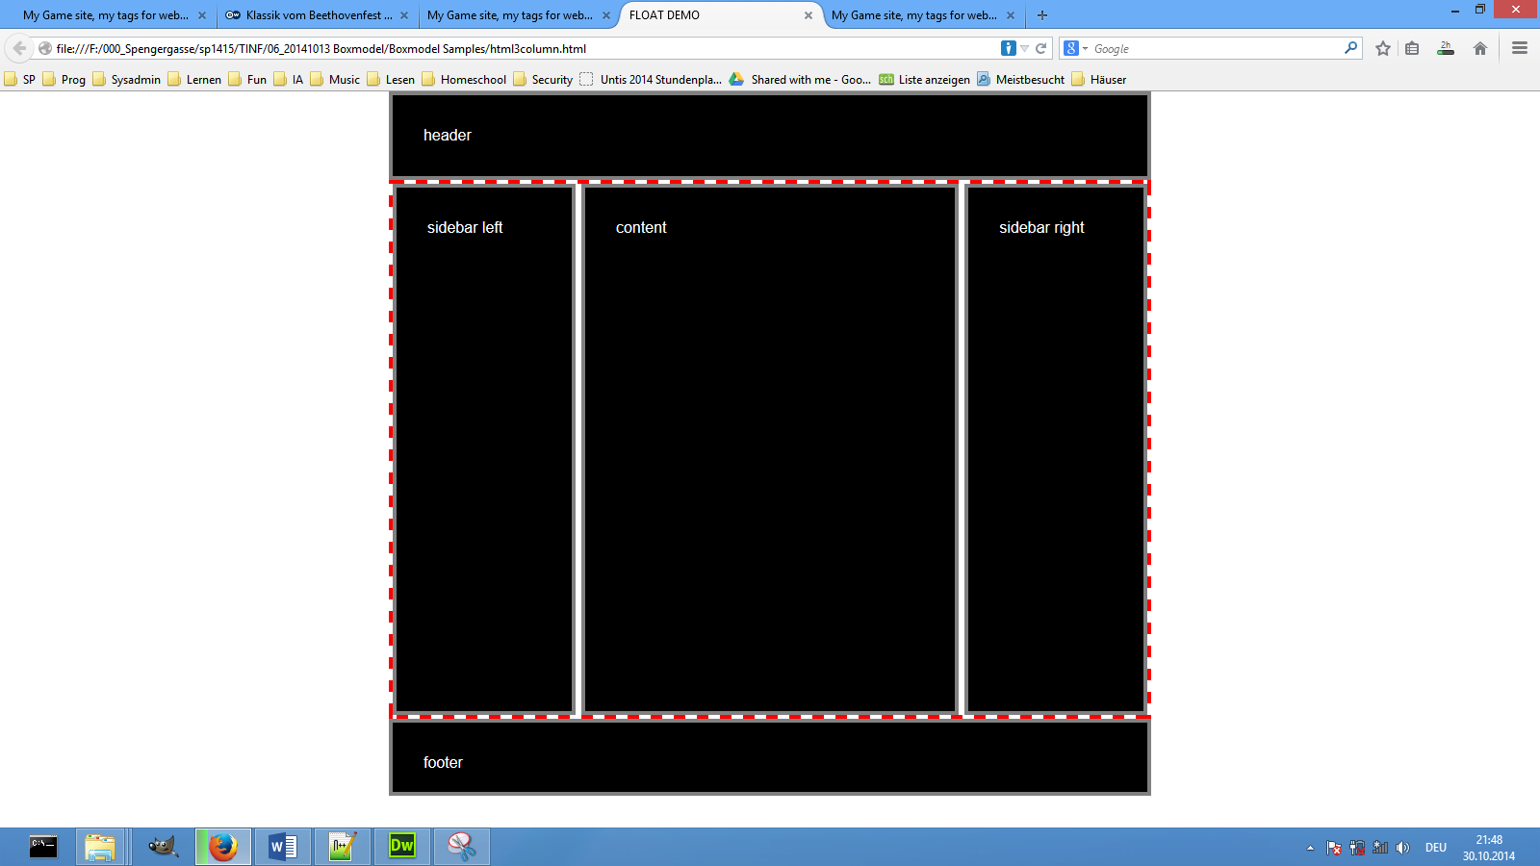

**Create a file structure**: css, images folder

Question of the day: What might be the reason for a behaviour shown below?

